**Demo 2b - Updating a NuGet Package**

**Using the Add Library Package Reference Dialog Box**

This topic describes how to update a NuGet package using the **Add Library Package Reference** dialog box.

In **Solution Explorer**, right-click the project, click **Add**, and then click **Add Library Package Reference**.

[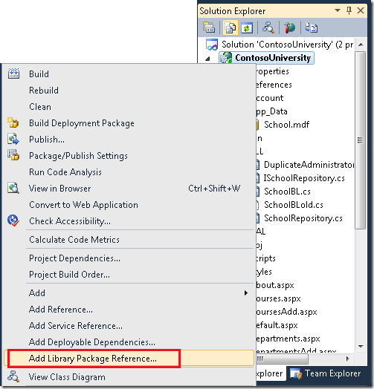](http://download.codeplex.com/Project/Download/FileDownload.aspx?ProjectName=nuget&DownloadId=189348)

The **Add Library Package Reference** dialog box opens with the **Installed Packages** tab selected and display installed packages.

[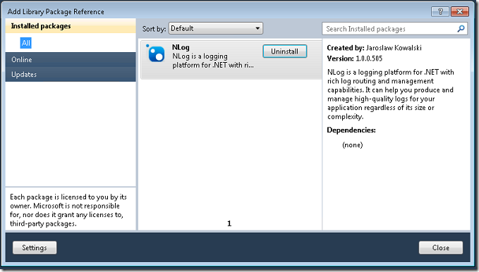](http://download.codeplex.com/Project/Download/FileDownload.aspx?ProjectName=nuget&DownloadId=187031)

Click the **Updates** tab. If there are newer version available for any of installed packages, they are displayed in the middle pane.

[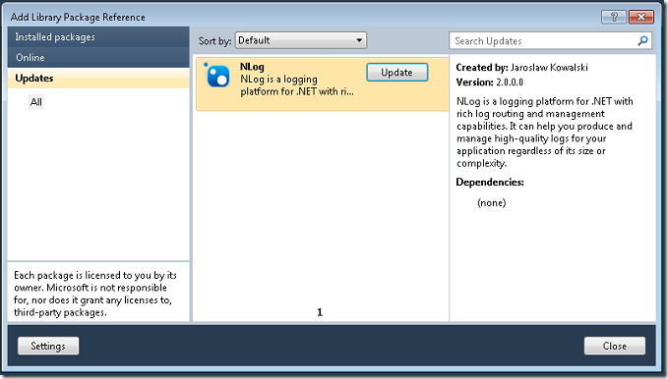](http://download.codeplex.com/Project/Download/FileDownload.aspx?ProjectName=nuget&DownloadId=187033)

Select the package to update and then click **Update**. When the new version is installed, the **Update** button turns into a green check mark.

[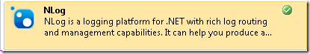](http://download.codeplex.com/Project/Download/FileDownload.aspx?ProjectName=nuget&DownloadId=189352)

# Using the Package Manager Console

This topic describes how to update a NuGet package using PowerShell commands. As an alternative, you can update packages using the **Add Library Package Reference** dialog box. For more information, see [Updating a NuGet Package Using the Add Library Package Reference Dialog Box](http://nuget.codeplex.com/wikipage?title=Updating%20a%20Package%20Using%20the%20Add%20Library%20Package%20Reference%20Dialog%20Box).

From the **Tools** menu, select **Library Package Manager** and then click **Package Manager Console**.

To check if there are newer versions available for any installed packages, enter get-package –updates at the prompt.

[[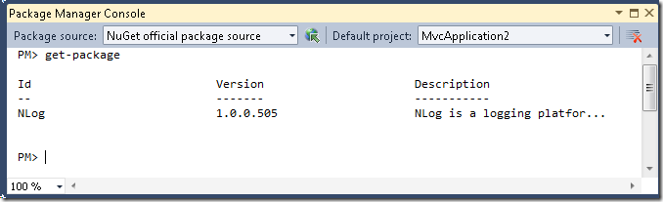](http://www.codeplex.com/Project/Download/FileDownload.aspx?ProjectName=nuget&DownloadId=168858)](http://www.codeplex.com/Project/Download/FileDownload.aspx?ProjectName=nuget&DownloadId=168858)To update a package, enter update-package with the package name. For example, enter the command update-package nlog. For more options that you can use with the update-package command, enter get-help update-package or see [Package manager Console Commands](http://nuget.codeplex.com/documentation?title=Package%20Manager%20Console%20Command%20Reference).

[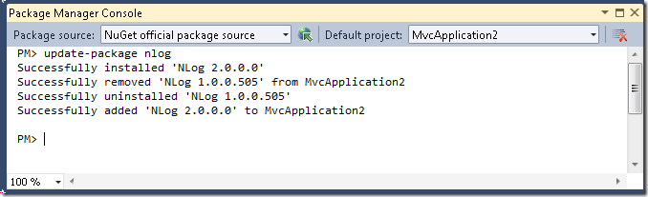](http://download.codeplex.com/Project/Download/FileDownload.aspx?ProjectName=nuget&DownloadId=189649)

You can verify that NuGet has installed the latest version of the specified package and removed the old one by listing the installed packages.

[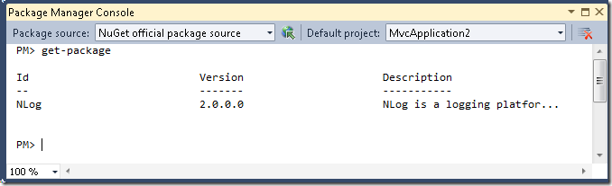](http://download.codeplex.com/Project/Download/FileDownload.aspx?ProjectName=nuget&DownloadId=189651)

If you no longer need the earlier version, you can uninstall it. For details, see [Removing a NuGet Package Using the Package Manager Console](http://nuget.codeplex.com/wikipage?title=Removing%20a%20Package%20Using%20the%20Package%20Manager%20Console).